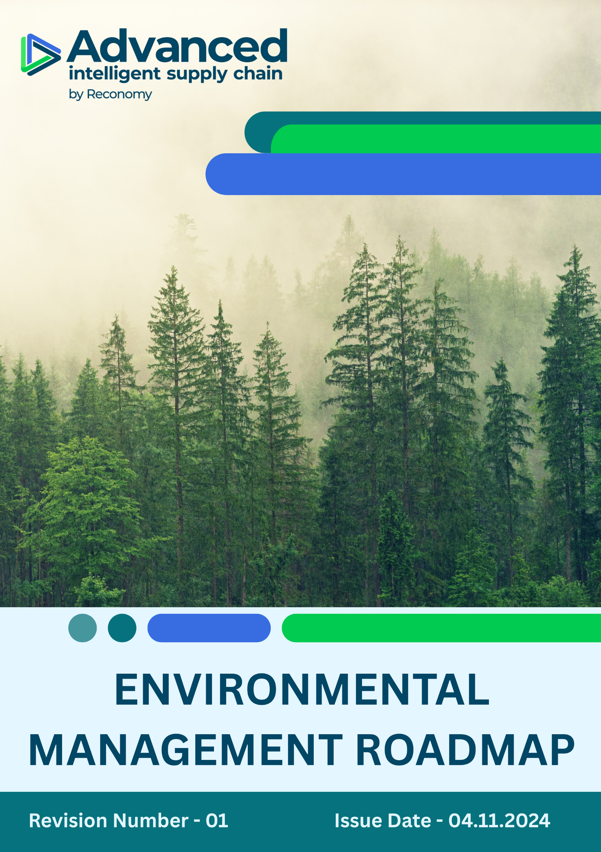

INDEX

⧫ Roadmap Introduction 3
⧫ Roadmap Scope 3
⧫ Objectives 3
⧫ Integrated Environmental Performance Targets 4
⧫ Governance and Allocation of Responsibilities 5
⧫ Review and Continual Improvement 5
⧫ Communication and Availability 5
⧫ Endorsement 6
⧫ Employee Acknowledgement Form 7

Roadmap Introduction
Advanced Supply Chain Group Limited (ASCG), a Reconomy Group company, is committed to environmental stewardship and responsible operations aligned with Reconomy’s sustainability ambitions. As part of our shared vision for a circular, low-carbon economy, we have developed this Environmental Management Roadmap outlines our strategic targets, key initiatives, and continuous improvement efforts..

This roadmap consolidates ASCG’s environmental commitments under key themes such as energy efficiency, GHG reduction, circularity, and employee advocacy — all designed to support compliance with ISO 14001:2015 and Reconomy’s ESG performance expectations.

Roadmap Scope
This Environmental Management Roadmap applies to all employees, stakeholders, contractors, partners, customers, contractual workers, and any individuals acting on behalf of Advanced Supply Chain Group Limited (ASCG).

It covers all ASCG operational, administrative, and strategic activities across the following sites and regions:

Country | Sites Name | Address
United Kingdom | Head Office – Bradford (J26) | Unit 4, Interchange Way, Oakenshaw, Bradford, BD12 7AZ
United Kingdom | ASCG Corby (Site 1) | Units 1–3, Eismann Way, Corby, Northamptonshire, NN17 5ZB
United Kingdom | ASCG Corby (Site 2) | Hunters Point, Brakey Road, Corby, Northamptonshire, NN17 5JE
United Kingdom | ASCG Sheffield | PLP Smithywood, 6 Cowley Way, Sheffield, S35 1QP
Hong Kong | Hong Kong | 21st Floor, Edinburgh Tower, The Landmark, 15 Queen’s Road Central, Hong Kong
UAE | ASCG International | Al Fattan Plaza, Airport Road, Office 712, Al Garhoud, Dubai, UAE
Germany | ASCG Germany – Nettetal | Herrenpfad-Süd 40, 41334 Nettetal, Deutschland

Objectives
ASCG is committed to achieving the following general environmental objectives:
- Compliance with all applicable legal, regulatory, and other obligations related to environmental performance.
- Prevention of pollution and minimisation of adverse environmental impacts through effective risk management.
- Continuous improvement of the Environmental Management System (EMS) in line with ISO 14001:2015 standards.
- Integration of environmental considerations into decision-making processes, operational controls, and procurement.
- Sustainability awareness and culture throughout all levels of the organisation and its supply chain.

Integrated Environmental Performance Targets
To translate our objectives into measurable outcomes, ASCG is committed to the following targets, with the respective baseline year being 2021:

- Energy Efficiency and Resource Use
- We aim to transition to renewable energy sources, with a goal of sourcing 100% of electricity from solar or wind power at our UK and international sites by 2028, reducing dependency on non-renewable sources

- Greenhouse Gas Emissions (GHG)
- Cut Scope 1, 2, and 3 greenhouse gas (GHG) emissions per unit shipped by 33.6% by 2028, supported by the evaluation of low-emission fleet technologies and the integration of carbon-reduction strategies into logistics, procurement, and operational planning.

- Waste Management and Circularity
- Achieve 100% waste diversion from landfill across all sites by 2028 through staff engagement on the waste hierarchy and replacing plastic packaging materials with sustainable alternatives.
- Eliminate 100 % of single‑use plastic packaging in outbound logistics by 2028, replacing it with recyclable or certified compostable alternatives across all fulfilment centres

- Environmental Services & Advocacy
- Organise at least three employee-led environmental activities annually — such as tree plantation drives, local clean-up events, or recycling awareness campaigns — to promote hands-on sustainability and environmental responsibility across all sites.
- ASCG will launch a “Green Logistics Innovation Program” by 2028 to collect employee ideas on sustainability and implement at least one initiative per year that drives measurable impact.

Governance and Allocation of Responsibilities
Environmental governance at ASCG is embedded into our organisational structure to ensure accountability and effective execution:

Function | Responsibilities
Board of Directors | Strategic oversight and resource commitment
Executive Leadership Team (ELT) | Approval of targets, and annual environmental plans
Compliance Advisor / HSE Team | Implementation, monitoring, legal compliance, EMS audits, and incident investigation
Site Environmental Champions | Local engagement, training delivery, and issue identification
All Employees | Adherence to EMS procedures and proactive participation in sustainability practices

Review and Continual Improvement
The roadmap will be reviewed annually by the Environmental Compliance Officer or sooner in response to:
- Changes in operations or environmental legislation
- Environmental incidents or audit findings
- Stakeholder or management feedback
- Changes to Reconomy Group sustainability strategies

The Management Review will evaluate effectiveness, alignment with group strategy, and opportunities for improvement.

Communication and Availability
- This roadmap is published on the company intranet and available to all staff, contractors, and suppliers.
- Training and refresher sessions are delivered to ensure alignment and participation.
- Staff at all levels are encouraged to contribute ideas through the Green Logistics Innovation Program.

Endorsement
This Environmental Roadmap is endorsed by ASCG senior leadership and reaffirms our responsibility to operate sustainably, reduce our carbon footprint, and help shape a circular economy — in alignment with Reconomy Group’s corporate vision.

Approved by:
Position: Environmental Compliance Officer
Issue Date: 04-11-2024 Next Review Date : 04-11-2025

Employee Acknowledgement Form
I acknowledge that I have read and understood the contents of the Environmental Management Roadmap issued by Advanced Supply Chain Group Limited (ASCG). I understand my role in supporting ASCG’s environmental goals, sustainability targets, and the roadmap actions outlined within.

I commit to:
- Supporting the principles and responsibilities described in this roadmap.
- Participating in environmental training, initiatives, and awareness campaigns.
- Reporting any environmental risks, incidents, or opportunities for improvement through the appropriate channels.
- Contributing to ASCG’s vision of a low-carbon, circular economy in alignment with Reconomy Group’s sustainability strategy.

By signing below, I confirm my understanding and agreement to align with and uphold the goals outlined in the ASCG Environmental Management Roadmap.

Employee Name:
Signature:
Date:

